

LeisureLink Message Integration Specification

Version 1.0

March 2008

Table of Contents

Introduction 3
LL_RateAvailNotifRQ 3
Schema Overview 3
Schema Definition 3
Sample Message 4
LL_RateAvailNotifRQ 5
Schema Overview 5
Schema Definition 6
Sample Message 7
OTA_HotelAvailRQ 9
Schema Overview 9
Schema Definition 9
Sample Message 10
OTA_HotelAvailRS 11
Schema Overview 11
Schema Definition 11
Sample Message 13
OTA_HotelResRQ 15
Schema Overview 15
Schema Definition 15
Sample Message 17
OTA_HotelResRS 19
Schema Overview 19
Schema Definition 19
Sample Message 21
OTA_HotelResModifyRQ 23
Schema Overview 23
Schema Definition 23
Sample Message 25
OTA_HotelResModifyRS 27
Schema Overview 27
Schema Definition 27
Sample Message 27
OTA_CancelRQ 28
Schema Overview 28
Schema Definition 28
Sample Message 28
OTA_CancelRS 29
Schema Overview 29
Schema Definition 29
Sample Message 30

Introduction

This document contains detailed information for each XML message supported by LeisureLink. Each message section contains a graphical representation of the schema, a detailed breakdown of each element and attribute in the message, as well as a sample message. Each message prefixed with “LL_” conforms to the LeisureLink standard schema where all messages prefixed with “OTA_” conform to a subset of the 2006A version of the OTA schema.

LL_RateAvailNotifRQ

Schema Overview

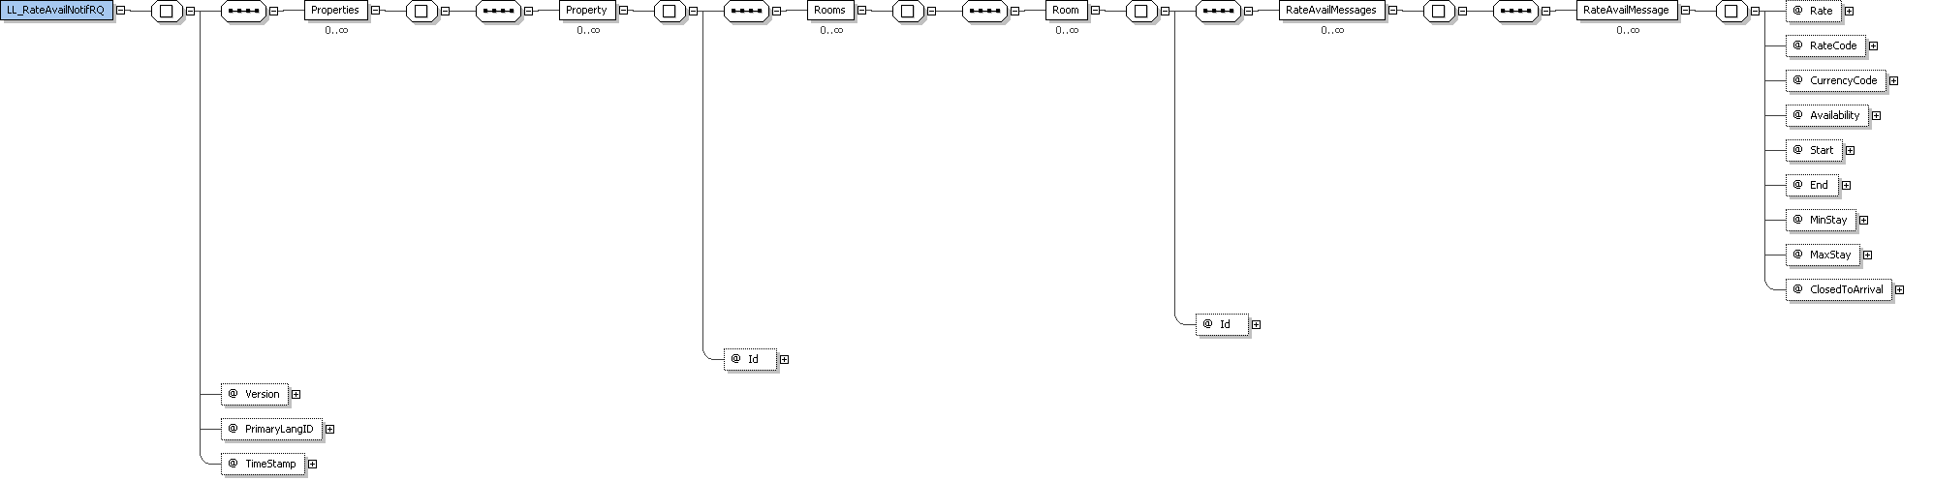

Schema Definition

Legend: L = level in the XML message | O = occurs
L | Element | Type | O | Description | Comments
0 | LL_RateAvailNotifRQ | - |  | Root element
 | xmlns | URL | 1 | Namespace of the message. | http://leisurelink.com/RAN/2008/02
 | Version | Decimal | 1 | Version of the message
 | PrimaryLangID | String | 1 | Language used in the message
 | TimeStamp | Date | 1 | Current date/time
1 | Properties | - | 1
2 | Property | - | 0..*
 | Id | String | 1 | The 5 character LeisureLink property code
3 | Rooms | - | 1
4 | Room | - | 1..*
 | Id | Integer | 1 | The LeisureLink room type ID
5 | RateAvailMessages | - | 1
6 | RateAvailMessage | - | 1..*
 | Rate | Decimal | 1 | Rack rate or rate for the specified rate code
 | RateCode | String | 1
 | CurrencyCode | String | 1 |  | “USD”
 | Availability | Integer | 1 | Total number of rooms types available
 | Start | Date | 1 |  | Format: YYYY-MM-DD
 | End | Date | 1 |  | Format: YYYY-MM-DD
 | MinStay | Integer | 1 | Minimum number of nights that must be booked
 | MaxStay | Integer | 1 | Maximum number of nights that can be booked
 | ClosedToArrival | Bit | 1 | The reservation date cannot start on this date | “0” or “1”

Sample Message

<LL_RateAvailNotifRQ Version="1.000" PrimaryLangID="en-us" TimeStamp="2008-02-05T13:51:44+02:00" xmlns="http://leisurelink.com/RAN/2008/02">
<Properties>
<Property Id="00001">
<Rooms>
<Room Id="1">
<RateAvailMessages>
<RateAvailMessage Rate="150.00" RateCode="RAC" CurrencyCode="USD" Availability="100" Start="2008-02-08" End="2008-02-09" MinStay="2" MaxStay="99" ClosedToArrival="0"/>
<RateAvailMessage Rate="150.00" RateCode="PKG" CurrencyCode="USD" Availability="100" Start="2008-02-08" End="2008-02-09" MinStay="2" MaxStay="99" ClosedToArrival="0"/>
<RateAvailMessage Rate="54.25" RateCode="RAC" CurrencyCode="USD" Availability="22" Start="2008-02-09" End="2008-02-10" MinStay="2" MaxStay="99" ClosedToArrival="0"/>
</RateAvailMessages>
</Room>
<Room Id="2">
<RateAvailMessages>
<RateAvailMessage Rate="88.00" RateCode="RAC" CurrencyCode="USD" Availability="77" Start="2008-02-08" End="2008-02-09" MinStay="3" MaxStay="99" ClosedToArrival="0"/>
</RateAvailMessages>
</Room>
</Rooms>
</Property>
<Property Id="00002">
<Rooms>
<Room Id="3">
<RateAvailMessages>
<RateAvailMessage Rate="78.00" RateCode="RAC" CurrencyCode="USD" Availability="99" Start="2008-02-08" End="2008-02-09" MinStay="5" MaxStay="14" ClosedToArrival="0"/>
<RateAvailMessage Rate="78.00" RateCode="RAC" CurrencyCode="USD" Availability="99" Start="2008-02-09" End="2008-02-10" MinStay="5" MaxStay="14" ClosedToArrival="1"/>
</RateAvailMessages>
</Room>
</Rooms>
</Property>
</Properties>
</LL_RateAvailNotifRQ>

LL_PropertyContentNotifRQ

Schema Overview
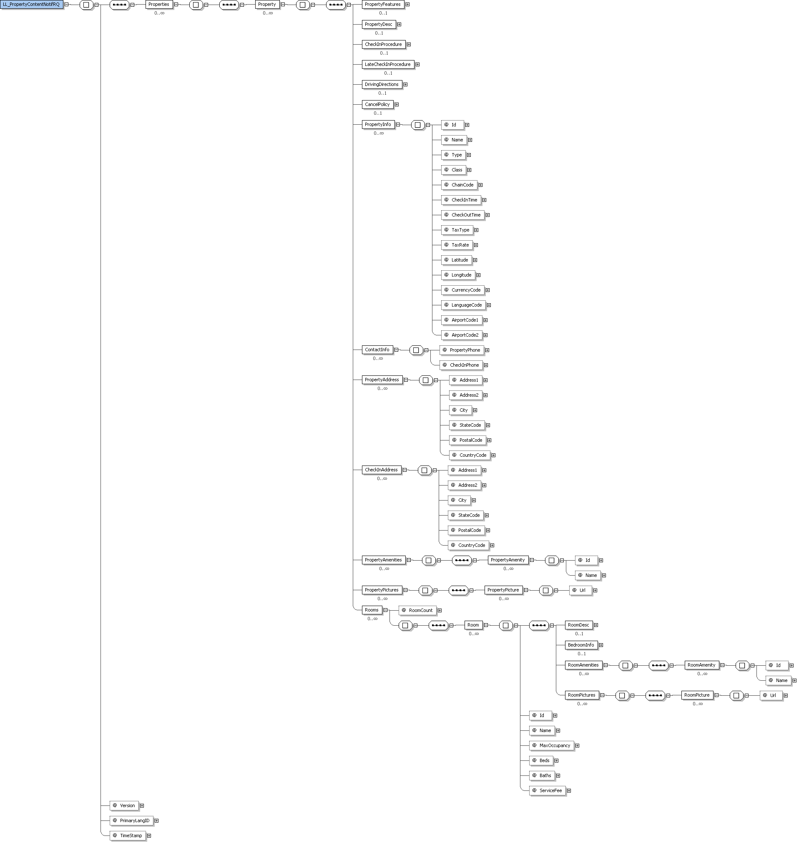

Schema Definition
Legend: L = level in the XML message | O = occurs
L | Element | Type | O | Description | Comments
0 | LL_PropertyContentNotifRQ | - |  | Root element
 | xmlns | URL | 1 | Namespace of the message. | http://leisurelink.com/PCN/2008/02
 | Version | Decimal | 1 | Version of the message
 | PrimaryLangID | String | 1 | Language used in the message
 | TimeStamp | Date | 1 | Current date/time
1 | Properties | - | 1
2 | Property | - | 0..*
3 | PropertyInfo | - | 1
 | Id | String | 1 | The 5 character LeisureLink property code
 | Name | String | 1 | Name of the property
 | Type | String | 1 | Type of property | i.e. Condo, Hotel, Suite, etc.
 | Class | String | 1 |  | i.e. Luxury, Standard, etc.
 | ChainCode | String | 1 | The LeisureLink chain code | “LI”
 | CheckInTime | String | 1 |  | i.e. 4:00PM or 11:00AM
 | CheckOutTime | String | 1
 | TaxType | String | 1 |  | “P” = percentage; “F” = flat rate
 | TaxRate | Decimal | 1 | The tax rate percentage or flat rate
 | Latitude | Decimal | 1
 | Longitude | Decimal | 1
 | CurrencyCode | String | 1 |  | “USD”
 | LanguageCode | String | 1 |  | “eng-us”
 | AirportCode1 | String | 1 | Primary airport
 | AirportCode2 | String | 1 | Secondary airport
3 | ContactInfo | - | 1
4 | PropertyPhone | String | 1 | Local contact at the property
4 | CheckInPhone | String | 1 | Phone number to call for check-in inquiries
4 | PropertyFeatures | String | 1
4 | PropertyDesc | String | 1
4 | CheckInProcedure | String | 1
4 | LateCheckInProcedure | String | 1
4 | DrivingDirections | String | 1
4 | CancelPolicy | String | 1
4 | PropertyAddress | - | 1
 | Address1 | String | 1
 | Address2 | String | 1
 | City | String | 1
 | StateCode | String | 1
 | PostalCode | String | 1
 | CountryCode | String | 1
4 | CheckInAddress | - | 0..1
 | Address1 | String | 1
 | Address2 | String | 1
 | City | String | 1
 | StateCode | String | 1
 | PostalCode | String | 1
 | CountryCode | String | 1
4 | PropertyAmenities | - | 1
5 | PropertyAmenity | - | 0..*
 | Id | Integer | 1 | Unique ID of the property amenity
 | Name | String | 1 | Name of the amenity
4 | PropertyPictures | - | 1
5 | PropertyPicture | - | 0..*
 | Url | URL | 1 | URL to the picture of the property hosted at LeisureLink
4 | Rooms | - | 1
 | RoomCount | Integer | 0..* | Total number of room types
5 | Room | - | 1
 | Id | Integer | 1 | The LeisureLink room type ID
 | Name | String | 1 | Descriptive name of the room
 | MaxOccupancy | Integer | 1
 | Beds | Integer | 1
 | Baths | Integer | 1
 | ServiceFee | Integer | 1 | Flat service fee for the entire booking
6 | RoomDesc | String | 1
6 | BedroomInfo | String | 1
6 | RoomAmenities | - | 1
7 | RoomAmenity | - | 0..*
 | Id | Integer | 1 | Unique ID of the property amenity
 | Name | String | 1 | Name of the amenity
7 | RoomPictures | - | 1
8 | RoomPicture | - | 0..*
 | Url | URL | 1 | URL to the picture of the room hosted at LeisureLink

Sample Message

<LL_PropertyContentNotifRQ Version="1.000" PrimaryLangID="en-us" TimeStamp="2008-02-05T13:51:44+02:00" xmlns="http://leisurelink.com/PCN/2008/02">
<Properties>
<Property>
<PropertyInfo Id="00001" Name="Summit Condos" Type="Hotel" Class="Luxury" ChainCode="LI" CheckInTime="4:00 PM" CheckOutTime="11:00 AM" TaxType="P" TaxRate="12.000" Latitude="37.6368" Longitude="-118.9862" CurrencyCode="USD" LanguageCode="eng-us" AirportCode1="ABC" AirportCode2="XYZ"/>
<ContactInfo PropertyPhone="111-111-1111" CheckInPhone="222-222-2222"/>
<PropertyFeatures>Guests of Summit will enjoy the soothing outdoor jacuzzi, weight room, underground parking, tennis courts and spas.</PropertyFeatures>
<PropertyDesc>Located at the base of chair 15, this beautiful complex offers the convenience of walking to the lifts, and a quiet location. Enjoy underground parking, a spacious weight room, pool, tennis and outdoor spas - located on the shuttle route just minutes from town!</PropertyDesc>
<CheckInProcedure>To check-in and check-out you MUST go to the Summit Office located at 3253 Meridian Boulevard. The office is open 9am to 6pm. Cleaning fee is $65.00</CheckInProcedure>
<LateCheckInProcedure>If you arrive after 6pm, you will still need to go to the Summit Office. As you walk in the front door, there will be an unlocked wooden box located on your left. Open the box, there will be an envelope with your name on it. Inside will be a parking pass, key, and directions to the unit.</LateCheckInProcedure>
<DrivingDirections>From Mammoth Airport. 1. Take US-395 N. 2. Turn left on CA-203W. 3. Go straight ahead past the 1st light. 4. After 2 more blocks turn left on the 2nd street. 5. Immediately turn right. 6. Mammoth Reservations will be on the left hand side.</DrivingDirections>
<CancelPolicy>If cancelled 45 or more days prior to check-in, a $50 USD cancellation penalty will be assessed. If cancelled less than 45 days prior to check-in, there is no refund.</CancelPolicy>
<PropertyAddress Address1="1234 Main Street" Address2="Suite 123" City="Anywhere" StateCode="CA" PostalCode="91311" CountryCode="USA"/>
<CheckInAddress Address1="1234 Property Street" Address2="3" City="Anywhere" StateCode="CA" PostalCode="91311" CountryCode="USA"/>
<PropertyAmenities>
<PropertyAmenity Id="10" Name="Swimming pool"/>
</PropertyAmenities>
<PropertyPictures>
<PropertyPicture Url="http://pics.leisurelink.com/X.jpg"/>
</PropertyPictures>
<Rooms RoomCount="1">
<Room Id="1" Name="4 bedroom" MaxOccupancy="4" Beds="4" Baths="2" ServiceFee="50">
<RoomDesc>This lovely one bedroom features all the comforts of home including a fully equipped kitchen, a spacious dining area, a television and VCR, a stereo and the luxury of a fireplace. Rate is based on double occupancy. A $15 charge will apply to each additional person.</RoomDesc>
<BedroomInfo>Unit bedding includes 1 Queen bed and 1 Queen sofa sleeper in the living room.</BedroomInfo>
<RoomAmenities>
<RoomAmenity Id="12" Name="Pets ok"/>
</RoomAmenities>
<RoomPictures>
<RoomPicture Url="http://pics.leisurelink.com/Y.jpg"/>
</RoomPictures>
</Room>
</Rooms>
</Property>
</Properties>
</LL_PropertyContentNotifRQ>

OTA_HotelAvailRQ

Schema Overview
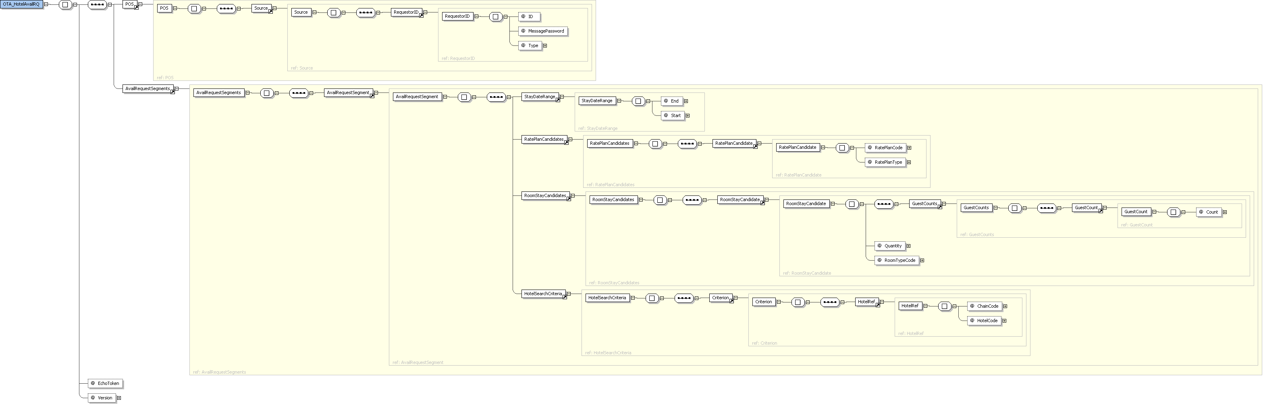

Schema Definition
Legend: L = level in the XML message | O = occurs
L | Element | Type | O | Description | Comments
0 | OTA_HotelAvailRQ | - |  | Root element
 | xmlns |  | 1 | Namespace of the message | http://www.opentravel.org/OTA/2003/05
 | EchoToken | String | 1 | A reference for additional message identification assigned by the Partner. When a value is provided, the same value will be returned in the response
 | Version | Decimal | 1 |  | “1.003”
1 | POS | - | 1
2 | Source | - | 1
2 | RequestorID | - | 1 |  | “99” for testing
 | Type | Integer | 1 |  | “13”
 | ID | Integer | 1 | The unique Partner ID provided by LeisureLink
 | MessagePassword | String | 1 | The password provided by LeisureLink | “LL$99test0814” for testing
1 | AvailRequestSegments | - | 1
2 | AvailRequestSegment | - | 1
3 | StayDateRange | - | 1
 | Start | Date | 1 | The start date of the reservation | Format: YYYY-MM-DD
 | End | Date | 1 | The date of checkout (the reservation stay will be start date to end date – 1) | Format: YYYY-MM-DD
1 | RatePlanCandidates | - | 1
2 | RatePlanCandidate | - | 1
 | RatePlanCode | String | 1 | The rate plan code requested (the rack rate will be returned if no value is provided)
 | RatePlanType | String | 1 |  | “13”
1 | RoomStayCandidates | - | 1
2 | RoomStayCandidate | - | 1
 | Quantity | Integer | 1 | The number of rooms requested
 | RoomTypeCode | Integer | 1 | The LeisureLink room type ID
3 | GuestCounts | - | 1
4 | GuestCount | - | 1
 | Count | Integer | 1 | The total number of guests staying in each room (including children)
1 | HotelSearchCriteria | - | 1
2 | Criterion | - | 1
3 | HotelRef | - | 1
 | ChainCode | String | 1 | The LeisureLink chain code | “LI”
 | HotelCode | String | 1 | The 5 character LeisureLink property code

Sample Message

<OTA_HotelAvailRQ EchoToken=" " Version="1.003" xmlns="http://www.opentravel.org/OTA/2003/05">
<POS>
<Source>
<RequestorID Type="13" ID="" MessagePassword="" />
</Source>
</POS>
<AvailRequestSegments>
<AvailRequestSegment>
<StayDateRange Start="2008-04-30" End="2008-05-11" />
<RatePlanCandidates>
<RatePlanCandidate RatePlanCode="RAC" RatePlanType="13" />
</RatePlanCandidates>
<RoomStayCandidates>
<RoomStayCandidate Quantity="1" RoomTypeCode="1">
<GuestCounts>
<GuestCount Count="1" />
</GuestCounts>
</RoomStayCandidate>
</RoomStayCandidates>
<HotelSearchCriteria>
<Criterion>
<HotelRef ChainCode="LI" HotelCode="00001" />
</Criterion>
</HotelSearchCriteria>
</AvailRequestSegment>
</AvailRequestSegments>
</OTA_HotelAvailRQ>

OTA_HotelAvailRS

Schema Overview
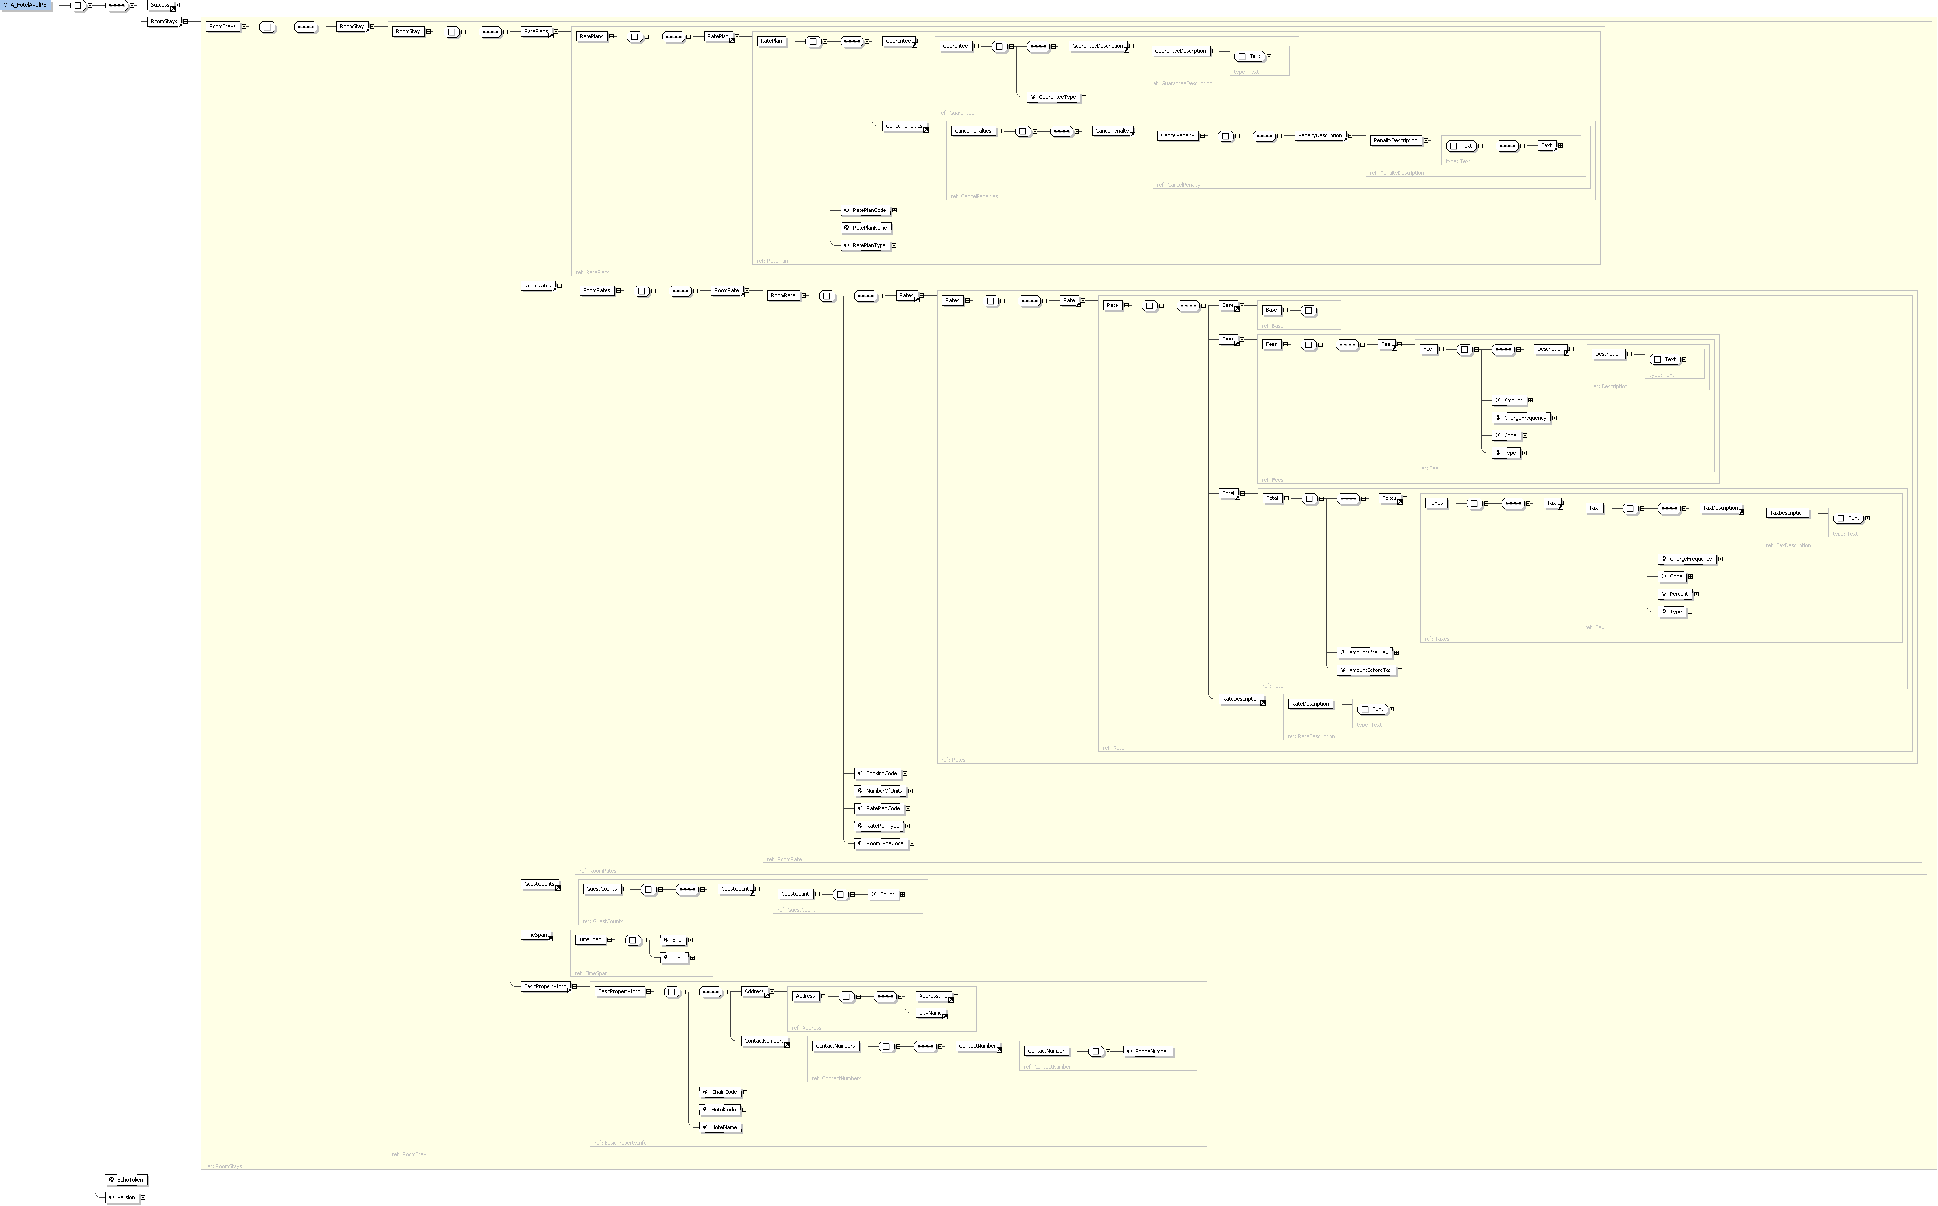

Schema Definition
Legend: L = level in the XML message | O = occurs
L | Element | Type | O | Description | Comments
0 | OTA_HotelAvailRS | - |  | Root element
 | xmlns |  | 1 | Namespace of the message | http://www.opentravel.org/OTA/2003/05
 | EchoToken | String | 1 | A reference for additional message identification assigned by the Partner. When a value is provided, the same value will be returned in the response.
 | Version | Decimal | 1 |  | “1.003”
 | TransactionIdentifier | String | 1 |  | “Availability”
1 | Success | - | 0..1 | An indicator of whether the message was successful and does not contain errors
1 | Errors | - | 0..1 | Only present when the Success element is not present
2 | Error | - | 0..*
 | Type | Integer | 0..* | The error code for the error returned
 | ShortText | String | 0..* | The error message
1 | RoomStays | - | 0..1 | Only present when the Success element is present
2 | RoomStay | - | 0..1
3 | RoomTypes | - | 0..1
4 | RoomType | - | 0..1
 | RoomTypeCode | Integer | 0..1 | The LeisureLink room type ID
5 | RoomDescription | - | 0..1
6 | Text | String | 0..1 | Description of the room type
6 | URL | Url | 0..1
3 | RoomRates | - | 0..1
3 | RoomRate | - | 0..1
 | BookingCode | Integer | 0..1 | A unique quote ID that guarantees the same rate when passed in the OTA_HotelResRQ message
 | RoomTypeCode | Integer | 0..1 | The LeisureLink room type ID
 | RatePlanCode | String | 0..1
 | RatePlanType | String | 0..1 |  | “13”
4 | Rates | - | 0..1
5 | Rate | - | 0..1
6 | Base | - | 0..1
 | AmountBeforeTax | Decimal | 0..1 | The individual room type price before tax
6 | Total | - | 0..1
 | AmountBeforeTax | Decimal | 0..1 | The total price for the reservation not including tax
 | AmountAfterTax | Decimal | 0..1 | The total price for the reservation including tax
7 | Taxes | - | 0..1
8 | Tax | - | 0..1
 | Code | Integer | 0..1 |  | “13”
 | Type | String | 0..1 |  | “Inclusive”
 | ChargeFrequency | Integer | 0..1 |  | “19”
 | Percent | Decimal | 0..1 | The tax percent charged | i.e. 12.25
9 | TaxDescription | - | 0..1
10 | Text | String | 0..1
6 | RateDescription | - | 0..1
7 | Text | String | 0..1
1 | Criteria | - | 0..1
2 | Criterion | - | 0..1
3 | HotelRef | - | 0..1
 | ChainCode | String | 0..1 | The LeisureLink chain code | “LI”
 | HotelCode | String | 0..1 | The 5 character LeisureLink property code
3 | StayDateRange | - | 0..1
 | Start | Date | 0..1 | The start date of the reservation | Format: YYYY-MM-DD
 | End | Date | 0..1 | The date of checkout (the reservation stay will be start date to end date – 1) | Format: YYYY-MM-DD
3 | RoomStayCandidates | - | 0..1
4 | RoomStayCandidate | - | 0..1
 | Quantity | Integer | 0..1 | The number of rooms requested
5 | GuestCounts | - | 0..1
6 | GuestCount | - | 0..1
 | Count | Integer | 0..1 | The total number of guests staying in each room (including children)
6 | TimeSpan | - | 0..1
 | Start | Date | 0..1
 | End | Date | 0..1
6 | BasicPropertyInfo | - | 0..1
 | ChainCode | String | 0..1
 | HotelCode | String | 0..1
 | HotelName | String | 0..1
7 | Address | - | 0..1
8 | AddressLine | String | 0..1
8 | CityName | String | 0..1
7 | ContactNumbers | - | 0..1
8 | ContactNumber | - | 0..1
 | PhoneNumber | String | 0..1

Sample Message
<?xml version='1.0' encoding='UTF-8'?>
<OTA_HotelAvailRS xmlns='http://www.opentravel.org/OTA/2003/05' EchoToken=' ' Version='1.003'>
<Success/>
<RoomStays>
<RoomStay>
<RatePlans>
<RatePlan RatePlanCode='RAC' RatePlanName='Leisurelink Standard Rate' RatePlanType='13'>
<Guarantee GuaranteeType='GuaranteeRequired'>
<GuaranteeDescription>
<Text><![CDATA[Full Payment will be due at the time of booking]]></Text>
</GuaranteeDescription>
</Guarantee>
<CancelPenalties>
<CancelPenalty>
<PenaltyDescription>
<Text><![CDATA[A $50.00 CANCELLATION FEE WILL APPLY IF CANCELLED 45 DAYS OR MORE PRIOR TO DATE OF ARRIVAL OTHERWISE A $1831.60 FEE WILL APPLY IF CANCELLED WITHIN 45 DAYS.]]></Text>
</PenaltyDescription>
</CancelPenalty>
</CancelPenalties>
</RatePlan>
</RatePlans>
<RoomRates>
<RoomRate BookingCode='714' RoomTypeCode='1' RatePlanCode='RAC' RatePlanType='13' NumberOfUnits='1'>
<Rates>
<Rate >
<Base />
<Fees>
<Fee Code='13' Type='Inclusive' ChargeFrequency='19' Amount='65.00'>
<Description>
<Text><![CDATA[Cleaning/Booking Fees]]></Text>
</Description>
</Fee>
</Fees>
<Total AmountBeforeTax='1606.00' AmountAfterTax='1831.60' >
<Taxes>
<Tax Code='13' Type='Inclusive' ChargeFrequency='19' Percent='10.00'>
<TaxDescription>
<Text><![CDATA[Sales Tax]]></Text>
</TaxDescription>
</Tax>
</Taxes>
</Total>
<RateDescription>
<Text><![CDATA[RATE PER ROOM ON THE LENGTH OF STAY]]></Text>
</RateDescription>
</Rate>
</Rates>
</RoomRate>
</RoomRates>
<GuestCounts>
<GuestCount Count='1'/>
</GuestCounts>
<TimeSpan Start='2008-04-30' End='2008-05-11'/>
<BasicPropertyInfo ChainCode='LI' HotelCode='111' HotelName='LeisureLink Condos'>
<Address>
<AddressLine><![CDATA[3253 LeisureLink Blvd ]]></AddressLine>
<CityName>Mammoth Lakes</CityName>
</Address>
<ContactNumbers>
<ContactNumber PhoneNumber='(760) 934-3000'/>
</ContactNumbers>
</BasicPropertyInfo>
</RoomStay>
</RoomStays>
</OTA_HotelAvailRS>

OTA_HotelResRQ

Schema Overview
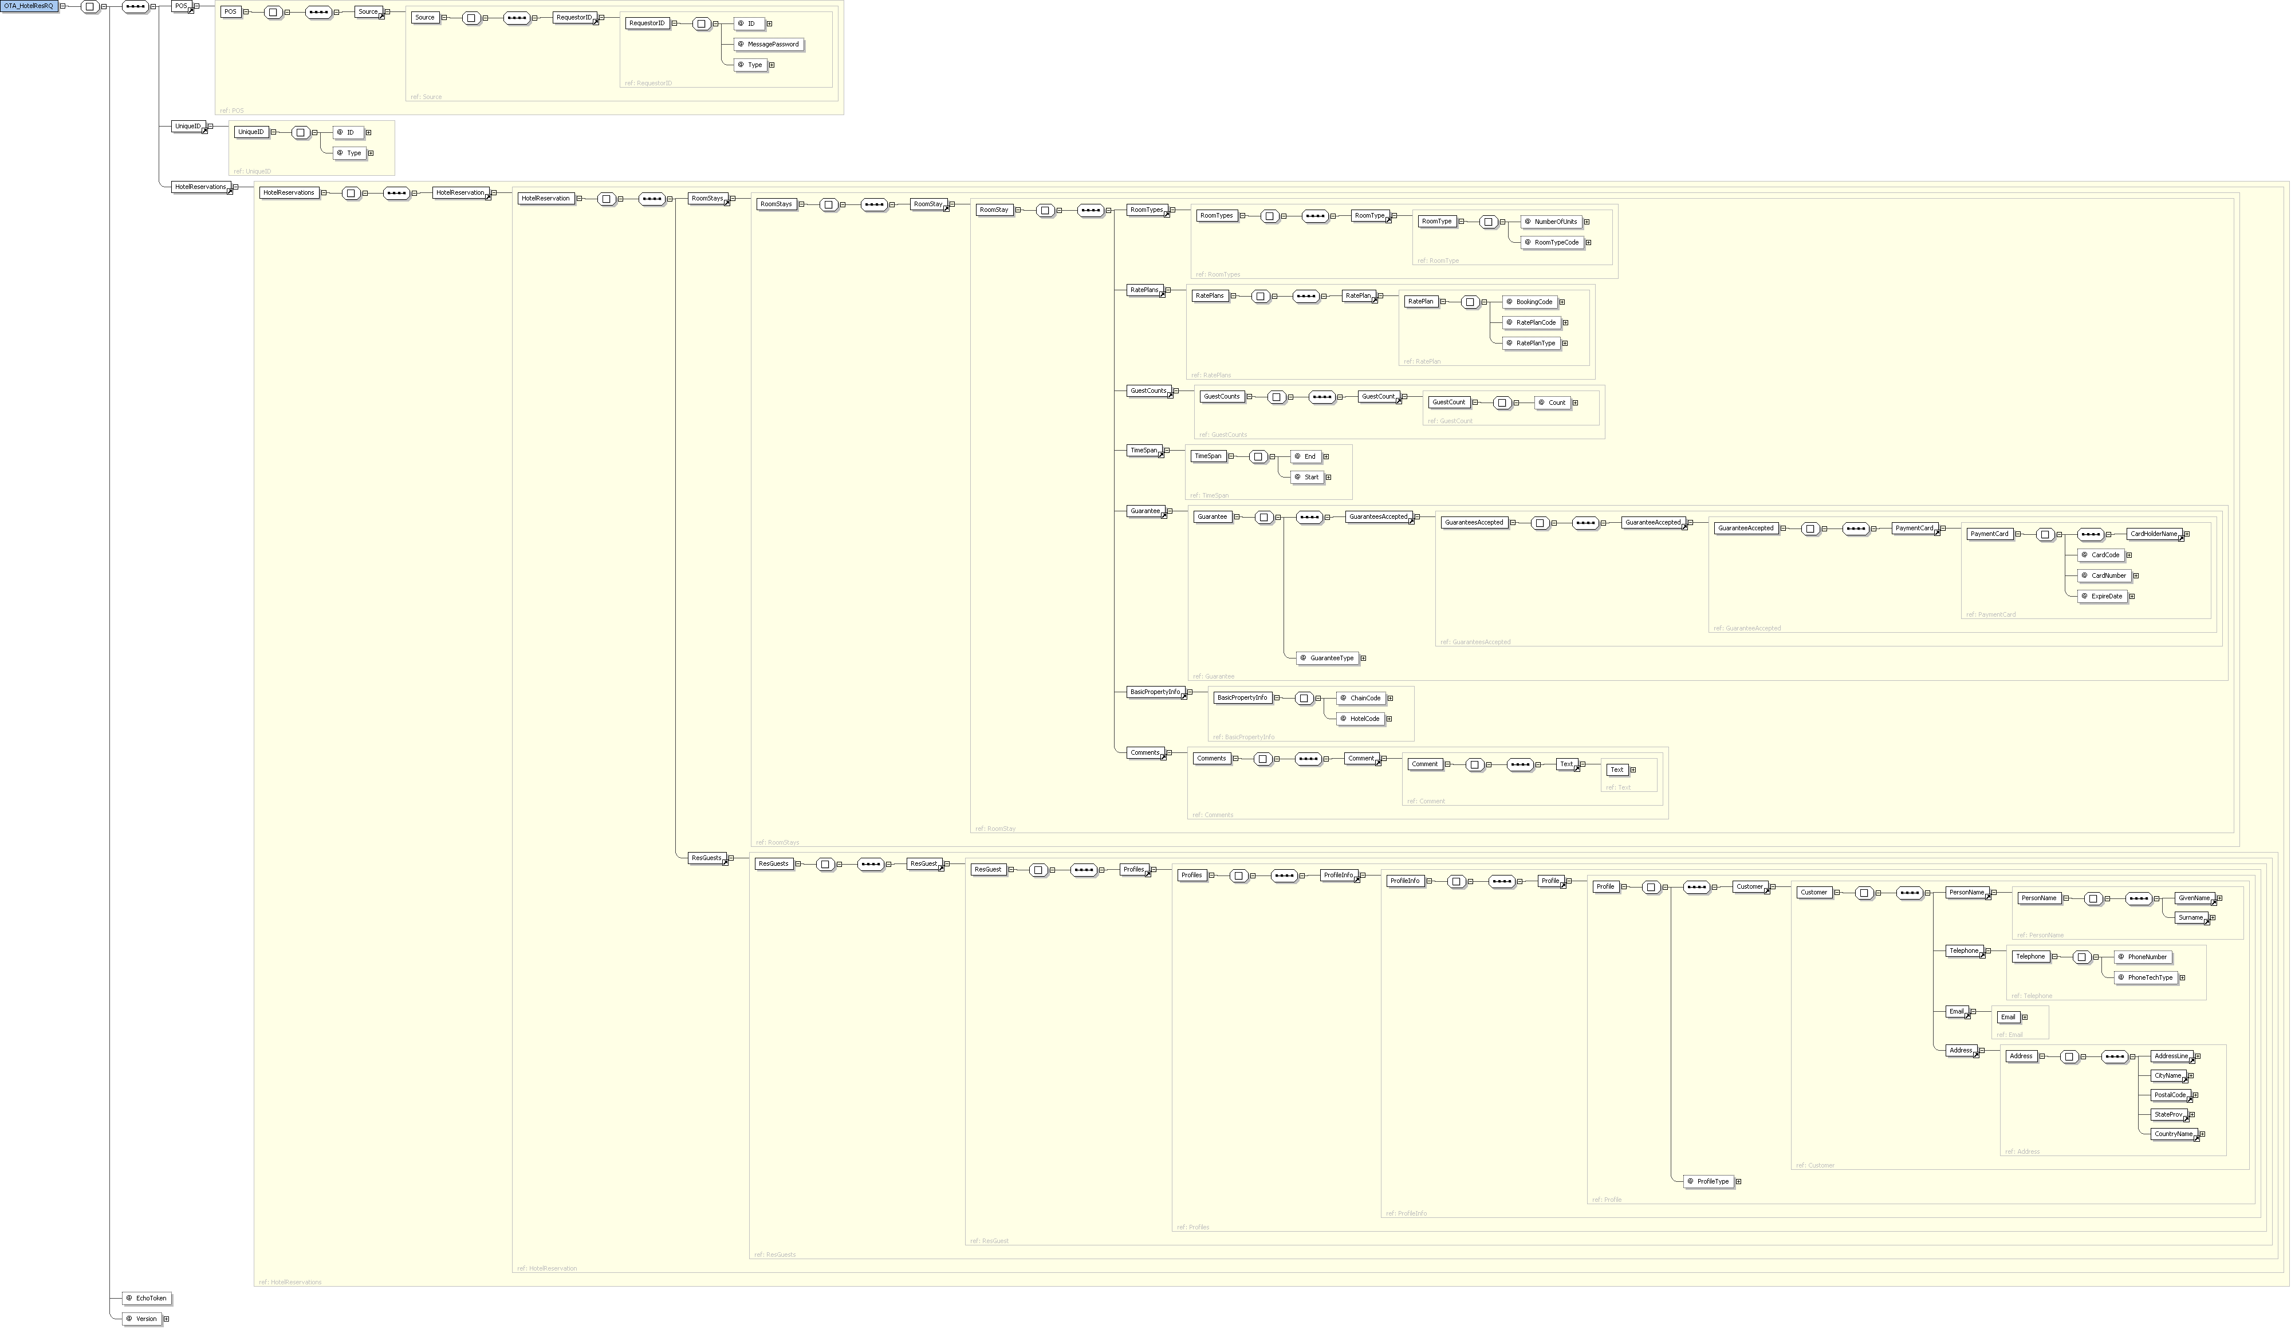

Schema Definition
Legend: L = level in the XML message | O = occurs
L | Element | Type | O | Description | Comments
0 | OTA_HotelResRQ | - |  | Root element
 | xmlns |  | 1 | Namespace of the message | http://www.opentravel.org/OTA/2003/05
 | EchoToken | String | 1 | A reference for additional message identification assigned by the Partner. When a value is provided, the same value will be returned in the response.
 | Version | Decimal | 1 |  | “1.003”
1 | POS | - | 1
2 | Source | - | 1
2 | RequestorID | - | 1 |  | “99” for testing
 | Type | Integer | 1 |  | “13”
 | ID | Integer | 1 | The unique Partner ID provided by LeisureLink
 | MessagePassword | String | 1 | The password provided by LeisureLink | “LL$99test0814” for testing
1 | UniqueID | - | 0..1
 | Type | Integer | 1 |  | “1”
 | ID | Integer | 1 | An optional unique Partner ID for the reservation
1 | HotelReservations | - | 1
2 | HotelReservation | - | 1
3 | RoomStays | - | 1
4 | RoomStay | - | 1
5 | RoomTypes | - | 1
6 | RoomType | - | 1
 | RoomTypeCode | Integer | 1 | The LeisureLink room type ID
 | NumberOfUnits | Integer | 1 | The number of rooms requested
4 | RatePlans | - | 1
5 | RatePlan | - | 1
 | BookingCode | Integer | 1 | The booking code (quote ID) returned in the OTA_HotelAvailRS message from a OTA_HotelAvailRQ availability request
 | RatePlanCode | String | 1 | The rate plan code requested (the rack rate will be returned if no value is provided)
 | RatePlanType | String | 1 |  | “13”
4 | GuestCounts | - | 1
5 | GuestCount | - | 1
 | Count | Integer | 1 | The total number of guests staying in each room (including children)
4 | TimeSpan | - | 1
 | Start | Date | 1 | The start date of the reservation | Format: YYYY-MM-DD
 | End | Date | 1 | The date of checkout (the reservation stay will be start date to end date – 1) | Format: YYYY-MM-DD
4 | Guarantee | - | 1
 | GuaranteeType | String | 1 |  | “GuaranteeRequired”
5 | GuaranteesAccepted | - | 1
6 | GuaranteeAccepted | - | 1
7 | PaymentCard | - | 1
 | CardCode | String | 1 | The 2 character code representing the type of card used | American Express: AX  MasterCard: MC  Diners Club: DC  Discover: DS  Visa: VI
 | CardNumber | String | 1 | The credit card number
 | ExpireDate | String | 1 | The 4 character code representing the month and year of expiration | i.e. 0215 for an expiration date of Feb 2015
 | CardHolderName | String | 1 | The name of the cardholder as it appears on the credit card
4 | BasicPropertyInfo | - | 1
 | ChainCode | String | 1 | The LeisureLink chain code | “LI”
 | HotelCode | String | 1 | The 5 character LeisureLink property code
4 | Comments | - | 1
5 | Comment | - | 1
 | Text | String | 1
3 | ResGuests | - | 1
4 | ResGuest | - | 1
5 | Profiles | - | 1
6 | ProfileInfo | - | 1
7 | Profile | - | 1
 | ProfileType |  | 1
8 | Customer | - | 1
9 | PersonName | - | 1
10 | GivenName | String | 1 | The first name of the guest
10 | Surname | String | 1 | The last name of the guest
9 | Telephone | - | 1
 | PhoneNumber | String | 1 | The phone number of the guest
 | PhoneTechType | Integer | 1 |  | “1”
9 | Email | String | 1 | The email address of the guest
9 | Address | String | 1
10 | AddressLine | String | 1 | The street address of the guest
10 | CityName | String | 1 | The city name of the guest
10 | PostalCode | String | 1 | The 5 character zip code of the guest
10 | StateProv | String | 1 | The 2 character state or province code of the guest
10 | CountryName | String | 1 | The 3 character country code of the guest

Sample Message
<OTA_HotelResRQ EchoToken=" " Version="1.003" xmlns="http://www.opentravel.org/OTA/2003/05">
<POS>
<Source>
<RequestorID Type="13" ID="" MessagePassword="" />
</Source>
</POS>
<UniqueID Type="1" ID="1958443" />
<HotelReservations>
<HotelReservation>
<RoomStays>
<RoomStay>
<RoomTypes>
<RoomType RoomTypeCode="1" NumberOfUnits="1" />
</RoomTypes>
<RatePlans>
<RatePlan BookingCode="714" RatePlanCode="RAC" RatePlanType="13" />
</RatePlans>
<GuestCounts>
<GuestCount Count="1" />
</GuestCounts>
<TimeSpan Start="2008-04-30" End="2008-05-11" />
<Guarantee GuaranteeType="GuaranteeRequired">
<GuaranteesAccepted>
<GuaranteeAccepted>
<PaymentCard CardCode="VI" CardNumber="4111111111111111" ExpireDate="0110">
<CardHolderName>LeisureLink</CardHolderName>
</PaymentCard>
</GuaranteeAccepted>
</GuaranteesAccepted>
</Guarantee>
<BasicPropertyInfo ChainCode="LI" HotelCode="111" />
<Comments>
<Comment>
<Text>Special Request</Text>
</Comment>
</Comments>
</RoomStay>
</RoomStays>
<ResGuests>
<ResGuest>
<Profiles>
<ProfileInfo>
<Profile ProfileType="1">
<Customer>
<PersonName>
<GivenName>Test</GivenName>
<Surname>LeisureLink</Surname>
</PersonName>
<Telephone PhoneNumber="11 626 696-1234 222" PhoneTechType="1" />
<Email>development@leisurelink.com</Email>
<Address>
<AddressLine>2555 E. Colorado Blvd.</AddressLine>
<CityName>Pasadena</CityName>
<PostalCode>91107</PostalCode>
<StateProv>CA</StateProv>
<CountryName>USA</CountryName>
</Address>
</Customer>
</Profile>
</ProfileInfo>
</Profiles>
</ResGuest>
</ResGuests>
</HotelReservation>
</HotelReservations>
</OTA_HotelResRQ>

OTA_HotelResRS

Schema Overview
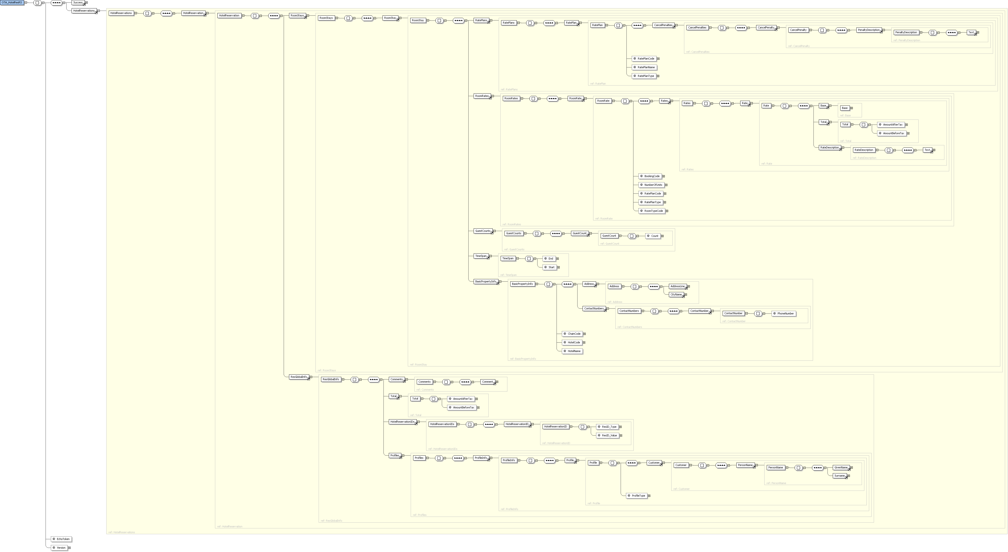

Schema Definition
Legend: L = level in the XML message | O = occurs
L | Element | Type | O | Description | Comments
0 | OTA_HotelResRS | - |  | Root element
 | xmlns |  | 1 | Namespace of the message | http://www.opentravel.org/OTA/2003/05
 | EchoToken | String | 1 | A reference for additional message identification assigned by the Partner. When a value is provided, the same value will be returned in the response.
 | Version | Decimal | 1 |  | “1.003”
1 | Success | - | 0..1 | An indicator of whether the message was successful and does not contain errors
1 | Errors | - | 0..1 | Only present when the Success element is not present
2 | Error | - | 0..*
 | Type | Integer | 0..* | The error code for the error returned
 | ShortText | String | 0..* | The error message
1 | HotelReservations | - | 0..1
2 | HotelReservation | - | 0..1
3 | RoomStays | - | 0..1
4 | RoomStay | - | 0..1
5 | RatePlans | - | 0..1
6 | RatePlan | - | 0..1
 | RatePlanCode | String | 0..1
 | RatePlanType | String | 0..1 |  | “13”
 | RatePlanName | String | 0..1 | Descriptive name of the rate plan
7 | Guarantee | - | 0..1
 | GuaranteeType | String | 0..1 |  | “GuaranteeRequired”
8 | GuaranteeDescription | - | 0..1
9 | Text | String | 0..1
7 | CancelPenalties | - | 0..1
8 | CancelPenalty | - | 0..1
9 | PenaltyDescription | - | 0..1
10 | Text | String | 0..1 | Cancellation policy
6 | RoomRates | - | 0..1
7 | RoomRate | - | 0..1
 | BookingCode | Integer | 0..1
 | RoomTypeCode | String | 0..1
 | RatePlanCode | String | 0..1
 | RatePlanType | String | 0..1
 | NumberOfUnits | Integer | 0..1 | The number of rooms requested
8 | Rates | - | 0..1
9 | Rate | - | 0..1
10 | Base | - | 0..1
 | AmountBeforeTax | Decimal | 0..1 | The individual room type price before tax
10 | Total | - | 0..1
 | AmountBeforeTax | Decimal | 0..1 | The total price for the reservation not including tax
10 | RateDescription | - | 0..1 | The total price for the reservation including tax
 | Text | String | 0..1
5 | GuestCounts | - | 0..1
6 | GuestCount | - | 0..1
 | Count | Integer | 0..1 | The total number of guests staying in each room (including children)
5 | TimeSpan | - | 0..1
 | Start | Date | 0..1 | The start date of the reservation | Format: YYYY-MM-DD
 | End | Date | 0..1 | The date of checkout | Format: YYYY-MM-DD
5 | BasicPropertyInfo | - | 0..1
 | ChainCode | String | 0..1 | The LeisureLink chain code | “LI”
 | HotelCode | String | 0..1 | The 5 character LeisureLink property code
 | HotelName | String | 0..1 | Name of the property
6 | Address | - | 0..1
7 | AddressLine | String | 0..1
7 | CityName | String | 0..1
7 | PostalCode | String | 0..1 | The 5 character zip code of the guest
7 | StateProv | String | 0..1 | The 2 character state or province code of the guest
7 | CountryName | String | 0..1 | The 3 character country code of the guest
6 | ContactNumbers | - | 0..1
7 | ContactNumber | - | 0..1
 | PhoneNumber | String | 0..1 | The phone number of the guest
3 | ResGlobalInfo | - | 0..1
4 | HotelReservationIDs | - | 0..1
5 | HotelReservationID | - | 0..1
 | ResID_Type | Integer | 0..1 |  | “14”
 | ResID_Value | String | 0..1 | The LeisureLink reservation confirmation number
4 | Profiles | - | 0..1
5 | ProfileInfo | - | 0..1
6 | Profile | - | 0..1
7 | ProfileType | String | 0..1 |  | “1”
8 | Customer | - | 0..1
9 | PersonName | - | 0..1
10 | GivenName | String | 0..1 | The first name of the guest
10 | Surname | String | 0..1 | The last name of the guest

Sample Message
<?xml version='1.0' encoding='UTF-8'?>
<OTA_HotelResRS xmlns='http://www.opentravel.org/OTA/2003/05' EchoToken=' ' Version='1.003'>
<Success/>
<HotelReservations>
<HotelReservation>
<RoomStays>
<RoomStay>
<RatePlans>
<RatePlan RatePlanCode='RAC' RatePlanName='Leisurelink Standard Rate' RatePlanType='13'>
<CancelPenalties>
<CancelPenalty>
<PenaltyDescription>
<Text><![CDATA[A $50.00 CANCELLATION FEE WILL APPLY IF CANCELLED 45 DAYS OR MORE PRIOR TO DATE OF ARRIVAL OTHERWISE A $1831.60 FEE WILL APPLY IF CANCELLED WITHIN 45 DAYS.]]></Text>
</PenaltyDescription>
</CancelPenalty>
</CancelPenalties>
</RatePlan>
</RatePlans>
<RoomRates>
<RoomRate BookingCode='714' RoomTypeCode='1' RatePlanCode='RAC' RatePlanType='13' NumberOfUnits='1'>
<Rates>
<Rate >
<Base />
<Total AmountBeforeTax='1606.00' AmountAfterTax='1831.60' ></Total>
<RateDescription>
<Text><![CDATA[RATE PER ROOM ON THE LENGTH OF STAY]]></Text>
</RateDescription>
</Rate>
</Rates>
</RoomRate>
</RoomRates>
<GuestCounts>
<GuestCount Count='1'/>
</GuestCounts>
<TimeSpan Start='2008-04-30' End='2008-05-11'/>
<BasicPropertyInfo ChainCode='LI' HotelCode='111' HotelName='Summit Condos'>
<Address>
<AddressLine><![CDATA[3253 LeisureLink Blvd ]]></AddressLine>
<CityName>Mammoth Lakes</CityName>
</Address>
<ContactNumbers>
<ContactNumber PhoneNumber='(760) 934-3000'/>
</ContactNumbers>
</BasicPropertyInfo>
</RoomStay>
</RoomStays>
<ResGlobalInfo>
<Comments>
<Comment>
<Text><![CDATA[CHECKIN TIME - 1/1/0001 12:00:00 AM CHECKOUT TIME - 1/1/1900 12:00:00 AM]]></Text>
<Text><![CDATA[RESERVATION GUARANTEED TO CREDIT CARD]]></Text>
<Text><![CDATA[THANK YOU FOR CHOOSING LeisureLink Condos]]></Text>
</Comment>
</Comments>
<Total AmountBeforeTax='1606.00' AmountAfterTax='1831.60' ></Total>
<HotelReservationIDs>
<HotelReservationID ResID_Type='14' ResID_Value='L94HXE97ZB500' />
</HotelReservationIDs>
<Profiles>
<ProfileInfo>
<Profile ProfileType='1'>
<Customer>
<PersonName>
<GivenName><![CDATA[Test]]></GivenName>
<Surname><![CDATA[LeisureLink]]></Surname>
</PersonName>
</Customer>
</Profile>
</ProfileInfo>
</Profiles>
</ResGlobalInfo>
</HotelReservation>
</HotelReservations>
</OTA_HotelResRS>

OTA_HotelResModifyRQ

Schema Overview
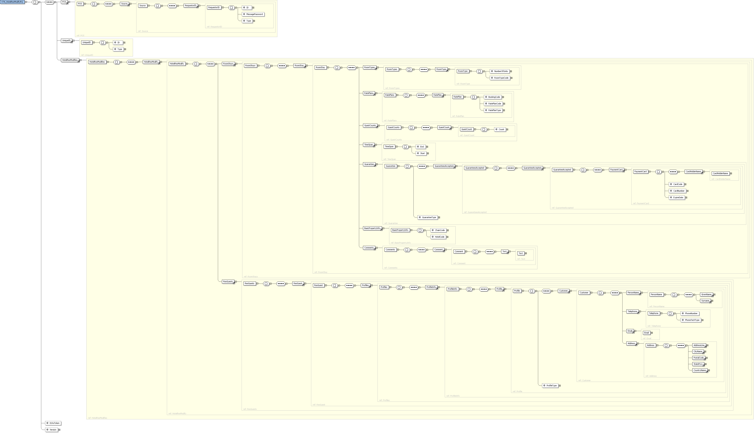

Schema Definition
Legend: L = level in the XML message | O = occurs
L | Element | Type | O | Description | Comments
0 | OTA_HotelResModifyRQ | - |  | Root element
 | xmlns |  | 1 | Namespace of the message | http://www.opentravel.org/OTA/2003/05
 | EchoToken | String | 1 | A reference for additional message identification assigned by the Partner. When a value is provided, the same value will be returned in the response.
 | Version | Decimal | 1 |  | “1.003”
1 | POS | - | 1
2 | Source | - | 1
2 | RequestorID | - | 1 |  | “99” for testing
 | Type | Integer | 1 |  | “14”
 | ID | Integer | 1 | The unique Partner ID provided by LeisureLink
 | MessagePassword | String | 1 | The password provided by LeisureLink | “LL$99test0814” for testing
1 | UniqueID | - | 0..1
 | Type | Integer | 1 |  | “1”
 | ID | Integer | 1 | The LeisureLink reservation confirmation number to be modified
1 | HotelResModifies | - | 1
2 | HotelResModify | - | 1
3 | RoomStays | - | 1
4 | RoomStay | - | 1
5 | RoomTypes | - | 1
6 | RoomType | - | 1
 | RoomTypeCode | Integer | 1 | The LeisureLink room type ID
 | NumberOfUnits | Integer | 1 | The number of rooms requested
4 | RatePlans | - | 1
5 | RatePlan | - | 1
 | BookingCode | Integer | 1 | The booking code (quote ID) returned in the OTA_HotelAvailRS message from a OTA_HotelAvailRQ availability request
 | RatePlanCode | String | 1 | The rate plan code requested (the rack rate will be returned if no value is provided)
 | RatePlanType | String | 1 |  | “13”
4 | GuestCounts | - | 1
5 | GuestCount | - | 1
 | Count | Integer | 1 | The total number of guests staying in each room (including children)
4 | TimeSpan | - | 1
 | Start | Date | 1 | The start date of the reservation | Format: YYYY-MM-DD
 | End | Date | 1 | The date of checkout (the reservation stay will be start date to end date – 1) | Format: YYYY-MM-DD
4 | Guarantee | - | 1
 | GuaranteeType | String | 1 |  | “GuaranteeRequired”
5 | GuaranteesAccepted | - | 1
6 | GuaranteeAccepted | - | 1
7 | PaymentCard | - | 1
 | CardCode | String | 1 | The 2 character code representing the type of card used | American Express: AX  MasterCard: MC  Diners Club: DC  Discover: DS  Visa: VI
 | CardNumber | String | 1 | The credit card number
 | ExpireDate | String | 1 | The 4 character code representing the month and year of expiration | i.e. 0215 for an expiration date of Feb 2015
 | CardHolderName | String | 1 | The name of the cardholder as it appears on the credit card
4 | BasicPropertyInfo | - | 1
 | ChainCode | String | 1 | The LeisureLink chain code | “LI”
 | HotelCode | String | 1 | The 5 character LeisureLink property code
4 | Comments | - | 1
5 | Comment | - | 1
 | Text | String | 1
3 | ResGuests | - | 1
4 | ResGuest | - | 1
5 | Profiles | - | 1
6 | ProfileInfo | - | 1
7 | Profile | - | 1
 | ProfileType |  | 1
8 | Customer | - | 1
9 | PersonName | - | 1
10 | GivenName | String | 1 | The first name of the guest
10 | Surname | String | 1 | The last name of the guest
9 | Telephone | - | 1
 | PhoneNumber | String | 1 | The phone number of the guest
 | PhoneTechType | Integer | 1 |  | “1”
9 | Email | String | 1 | The email address of the guest
9 | Address | String | 1
10 | AddressLine | String | 1 | The street address of the guest
10 | CityName | String | 1 | The city name of the guest
10 | PostalCode | String | 1 | The 5 character zip code of the guest
10 | StateProv | String | 1 | The 2 character state or province code of the guest
10 | CountryName | String | 1 | The 3 character country code of the guest

Sample Message
<OTA_HotelResModifyRQ EchoToken=" " Version="1.003" xmlns="http://www.opentravel.org/OTA/2003/05">
<POS>
<Source>
<RequestorID Type="13" ID="" MessagePassword="" />
</Source>
</POS>
<UniqueID Type="14" ID="L94HXE97ZB500" />
<HotelResModifies>
<HotelResModify>
<RoomStays>
<RoomStay>
<RoomTypes>
<RoomType RoomTypeCode="1" NumberOfUnits="1" />
</RoomTypes>
<RatePlans>
<RatePlan BookingCode="716" RatePlanCode="RAC" RatePlanType="13" />
</RatePlans>
<GuestCounts>
<GuestCount Count="1" />
</GuestCounts>
<TimeSpan Start="2008-04-30" End="2008-05-11" />
<Guarantee GuaranteeType="GuaranteeRequired">
<GuaranteesAccepted>
<GuaranteeAccepted>
<PaymentCard CardCode="VI" CardNumber="4111111111111111" ExpireDate="0110">
<CardHolderName>LeisureLink</CardHolderName>
</PaymentCard>
</GuaranteeAccepted>
</GuaranteesAccepted>
</Guarantee>
<BasicPropertyInfo ChainCode="LI" HotelCode="111" />
<Comments>
<Comment>
<Text>Special Request</Text>
</Comment>
</Comments>
</RoomStay>
</RoomStays>
<ResGuests>
<ResGuest>
<Profiles>
<ProfileInfo>
<Profile ProfileType="1">
<Customer>
<PersonName>
<GivenName>Test</GivenName>
<Surname>LeisureLink</Surname>
</PersonName>
<Telephone PhoneNumber="11 626 696-1234 222" PhoneTechType="1" />
<Email>development@leisurelink.com</Email>
<Address>
<AddressLine>2555 E. Colorado Blvd.</AddressLine>
<CityName>Pasadena</CityName>
<PostalCode>91107</PostalCode>
<StateProv>CA</StateProv>
<CountryName>USA</CountryName>
</Address>
</Customer>
</Profile>
</ProfileInfo>
</Profiles>
</ResGuest>
</ResGuests>
</HotelResModify>
</HotelResModifies>
</OTA_HotelResModifyRQ>

OTA_HotelResModifyRS

Schema Overview
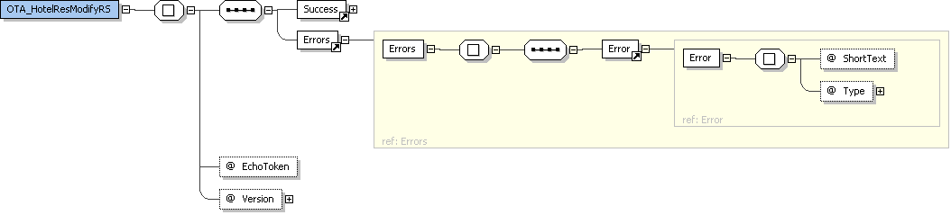

Schema Definition
Legend: L = level in the XML message | O = occurs
L | Element | Type | O | Description | Comments
0 | OTA_HotelResModifyRS | - |  | Root element
 | xmlns |  | 1 | Namespace of the message | http://www.opentravel.org/OTA/2003/05
 | EchoToken | String | 1 | A reference for additional message identification assigned by the Partner. When a value is provided, the same value will be returned in the response.
 | Version | Decimal | 1 |  | “1.003”
1 | Success | - | 0..1 | An indicator of whether the message was successful and does not contain errors
1 | Errors | - | 0..1 | Only present when the Success element is not present
2 | Error | - | 0..*
 | Type | Integer | 0..* | The error code for the error returned
 | ShortText | String | 0..* | The error message

Sample Message
<OTA_HotelResModifyRS xmlns='http://www.opentravel.org/OTA/2003/05' EchoToken=' ' Version='1.003'>
<Success/>
</OTA_HotelResModifyRS>

OTA_CancelRQ

Schema Overview
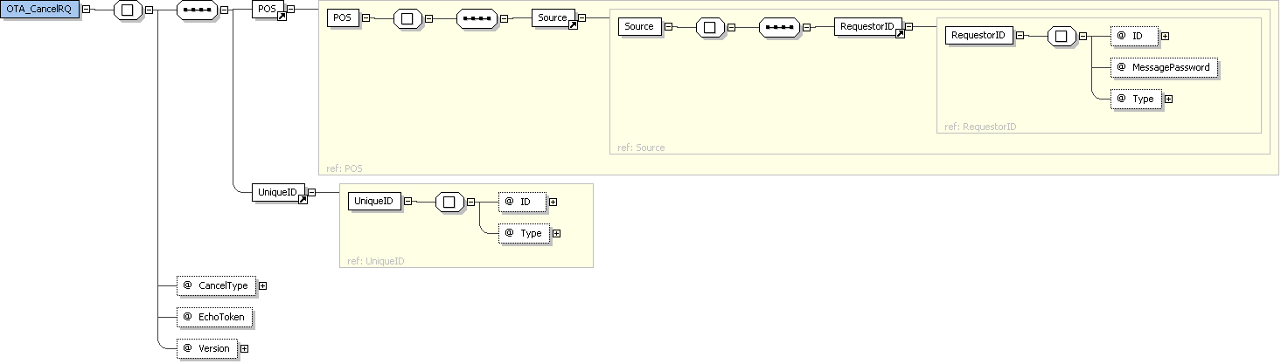

Schema Definition
Legend: L = level in the XML message | O = occurs
L | Element | Type | O | Description | Comments
0 | OTA_CancelRQ | - |  | Root element
 | xmlns |  | 1 | Namespace of the message | http://www.opentravel.org/OTA/2003/05
 | EchoToken | String | 1 | A reference for additional message identification assigned by the Partner. When a value is provided, the same value will be returned in the response.
 | Version | Decimal | 1 |  | “1.001”
1 | POS | - | 1
2 | Source | - | 1
2 | RequestorID | - | 1 |  | “99” for testing
 | Type | Integer | 1 |  | “13”
 | ID | Integer | 1 | The unique Partner ID provided by LeisureLink
 | MessagePassword | String | 1 | The password provided by LeisureLink | “LL$99test0814” for testing
1 | UniqueID | - | 0..1
 | Type | Integer | 1 |  | “14”
 | ID | Integer | 1 | The LeisureLink reservation confirmation number to be cancelled

Sample Message
<OTA_CancelRQ EchoToken=" " Version="1.001" CancelType="Commit" xmlns="http://www.opentravel.org/OTA/2003/05">
<POS>
<Source>
<RequestorID Type="13" ID="" MessagePassword="" />
</Source>
</POS>
<UniqueID Type="14" ID="L94HXE97ZB500" />
</OTA_CancelRQ>

OTA_CancelRS

Schema Overview
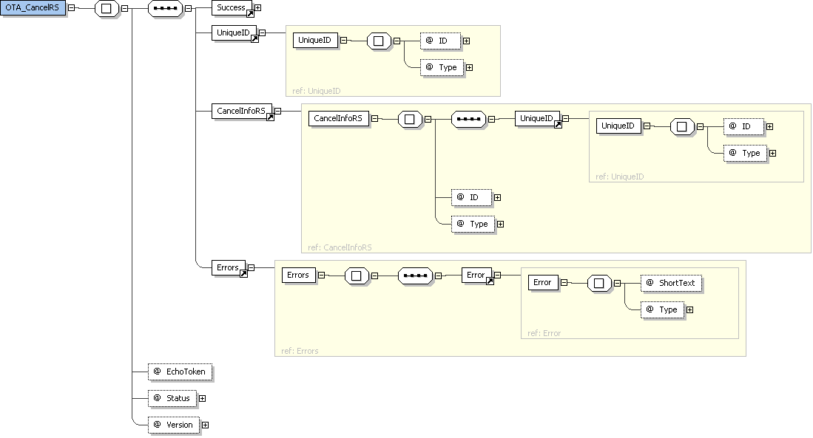

Schema Definition
Legend: L = level in the XML message | O = occurs
L | Element | Type | O | Description | Comments
0 | OTA_CancelRS | - |  | Root element
 | xmlns |  | 1 | Namespace of the message | http://www.opentravel.org/OTA/2003/05
 | EchoToken | String | 1 | A reference for additional message identification assigned by the Partner. When a value is provided, the same value will be returned in the response.
 | Version | Decimal | 1 |  | “1.001”
 | Status | String | 1 |  | “Cancelled”
1 | UniqueID | - | 1
 | Type | Integer | 1 |  | “14”
 | ID | String | 1 | The LeisureLink reservation confirmation number
2 | CancelInfoRS | - | 0..1
 | Type | Integer | 0..1 |  | “14”
 | ID | String | 0..1 | The LeisureLink reservation confirmation number
3 | UniqueID | - | 0..1
 | Type | Integer | 0..1 |  | “15”
 | ID | String | 0..1 | The LeisureLink cancellation number
1 | Success | - | 0..1 | An indicator of whether the message was successful and does not contain errors
1 | Errors | - | 0..1 | Only present when the Success element is not present
2 | Error | - | 0..*
 | Type | Integer | 0..* | The error code for the error returned
 | ShortText | String | 0..* | The error message

Sample Message
<?xml version='1.0' encoding='UTF-8'?>
<OTA_CancelRS xmlns='http://www.opentravel.org/OTA/2003/05' EchoToken=' ' Version='1.003' Status='Cancelled'>
<Success/>
<UniqueID Type='14' ID='L94HXE97ZB500' />
<CancelInfoRS Type='14' ID='L94HXE97ZB500'>
<UniqueID Type='15' ID='L94DUBJHSD515' />
</CancelInfoRS>
</OTA_CancelRS>

